Jeff Kinley

Seeing the End Times through the Eyes of Jesus of Nazareth
Current Considerations from the Olivet Discourse

Introduction
The Reality of the Last Days
Why Believe Jesus of Nazareth? Why Adopt His Version of the End Times?

An Overview of Jesus’ Prophecies
Jerusalem Will Be Destroyed (Matthew 24:1-2)
Humanity Will Be Deceived (Matthew 24:4-5, 11, 24-26)
Wars Will Be Fought (Matthew 24:6-8)
Believers Will Be Despised (Matthew 24:9-10)
Love Will Be Scarce (Matthew 24:12-13)
The Gospel Will Be Declared (Matthew 24:14)
The Temple Will Be Desecrated (Matthew 24:15-22)
The Antichrist Will Display Miracles (Matthew 24:23-26)

The Sign of the Son of Man
The Son of Man Will Descend from Heaven (Matthew 24:27-30)

The Context and Timing
Conclusion of Tribulation, the campaign of Armageddon begins. We typically think of a single great battle. However, Armageddon more of a campaign than a single battle. Culmination of seven years of divine judgments from God on the earth and its inhabitants. More people have died during the seven-year period than during any other conflict in history. From a human perspective, this bloody end is inevitable, as mankind will never achieve world peace on his own.
If Jesus Christ did not return, mankind would annihilate one another completely (Matthew 24:22). However, all this is part of God's grand plan.
“Armageddon” means Mount of Megiddo, and points to a geographical location approximately 60 miles north of Jerusalem. This area was previously the location of some Old Testament battles (Judges 4, 7). Spread out over 20,000 square miles.

The Condition of the World and Humanity.
What kind of world will Jesus encounter when He returns? What is the condition of mankind? How will they have responded to God’s judgments and seven years of “testing” (Rev. 3:10).

- Billions are Deluded and Deceived (2 Thessalonians 2:3-9)

- The Seal Judgments (Rev. 6) – Humanity’s Response?
- Kill Christians (6:9-11), Terror, no atheists (6:15-17). No evidence of repentance.

- The Trumpet Judgments (Rev. 8-9) Humanity’s Response?
- Suicide attempts (9:6)
- No Restrainer, and a resurgence of pagan idolatry
- Stubborn refusal to repent (9:20-21)

Prior to the Bowl Judgments, they take the mark of the beast and worship him (14:9-11).

- The Bowl Judgments (16:1-21) – Humanity’s Response?
- Blaspheme God (16:9). Refuse to repent (16:9)
Bowl Judgment #5 – Antichrist’s kingdom covered in thick darkness (16:10-11) “gnawed their tongues because of pain” psychological
Their response? – “blasphemed the God of Heaven” (16:11), hating and blaming Him instead of repenting. Always the “victim,” ever since the Garden (Gen. 3)
Now feeling the boiling hatred towards God, just like their father, the devil.

Bowl Judgment #6 – Three demons released to prepare for Armageddon (16:12-16)
Purpose? To rally the armies of the earth to fight the Lamb

Bowl Judgment #7 – Most powerful earthquake in history (16:17-21). This completes the Seal, Trumpet and Bowl Judgments (“It is done” 16:17). Babylon falls (16:19). Islands disappear and mountain ranges are levelled (16:20), possibly preparing the earth for the Millennial Kingdom. Topography is devasted. 100-lb hailstones come raining down from the sky, bringing unimaginable destruction (16:21).
Humanity’s Response? – They blaspheme God (16:21)

And mankind’s final response towards God? Humanity’s last stand? They assemble together, uniting for one final attempt to thwart God’s prophetic plan and Jesus’ prophesied reign upon the earth.
Revelation 19:19. Still hating. Still blaspheming. Still taunting. Still refusing to repent and believe.
We can trace mankind's downward spiral throughout the seven-year tribulation.
- First, they run and hide (6:15-17)
- Next they rebel against God and embrace their sin (9:20-21)
- Next, they reject God in favor of Antichrist, and seal their destiny (14:9-11)
- Then they blasphemed God and refused to repent (16:9, 11, 21)
- Finally, they gather together at Armageddon to kill God (16:14, 16; 17:14; 19:19)

Psalm 2:1-6

There is some debate as to the precise order of this battle campaign. However, the following is a generally accepted sequence and progression:

- At the sixth bowl judgment, the Euphrates River is dried up making it possible for the armies from the East to cross it (Revelation 16:12)

- Three demons performing supernatural signs lure Antichrist allies to Israel for the purpose of exterminating the Jews once and for all (Revelation 16:12-16)

- Jerusalem is attacked and falls (Zechariah 12:1-3; 14:2)

- Antichrist turns his attention South towards the Jewish remnant hiding in or near Petra, present-day Jordan (Isaiah 34:-7; 63:1-5; Joel 3:19; Matthew 24:15-31; Revelation 12:6,14). Since Jesus previously warned them to flee to the mountains (Matthew 24:16), many believe the ideal place of refuge will be near Bozrah or Petra, located about 80 miles south of Jerusalem, (see Micah 2:12-13; Daniel 11:41; Isaiah 63:1-3).
It is believed this mountainous region containing hundreds of clefts and caves, could protectively shelter around a million people. One-third of the Jews have been hiding there since the midpoint of the tribulation, since the abomination of desolation. This remnant will be divinely protected by God for 3 1/2 years. The other two-thirds were “cut off,” presumably slaughtered in the previous invasion of Israel and Jerusalem (Zechariah 13:8).

- Jesus Christ returns to Mount of Olives. No one on earth has seen this Christ except John for 2,000 years. Now He is returning in “power and great glory” (Matt. 24:27-30)

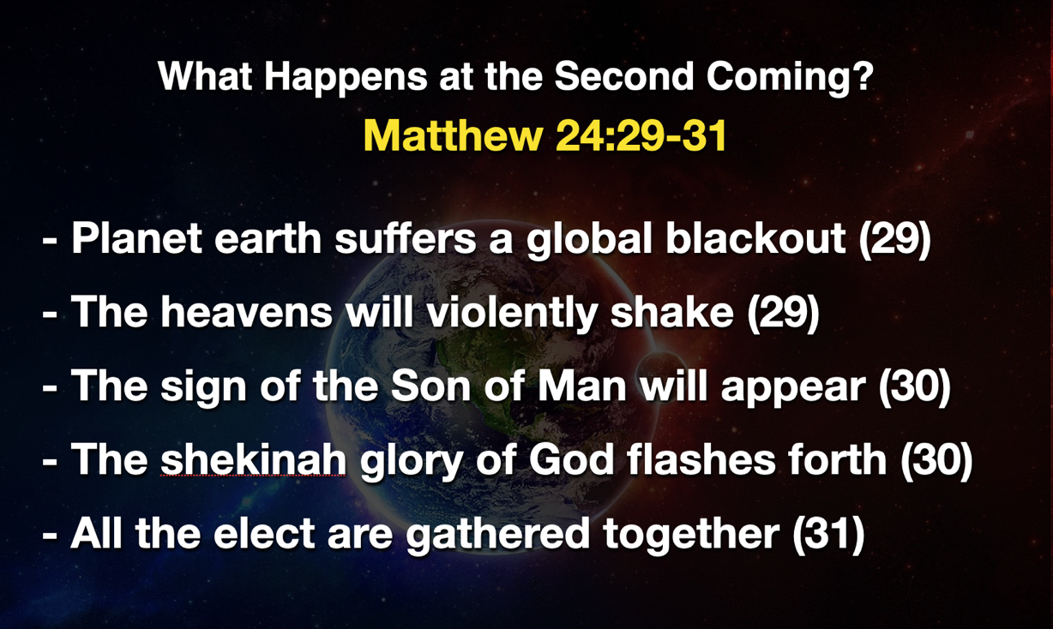

Many Confuse the Rapture with the Second Coming.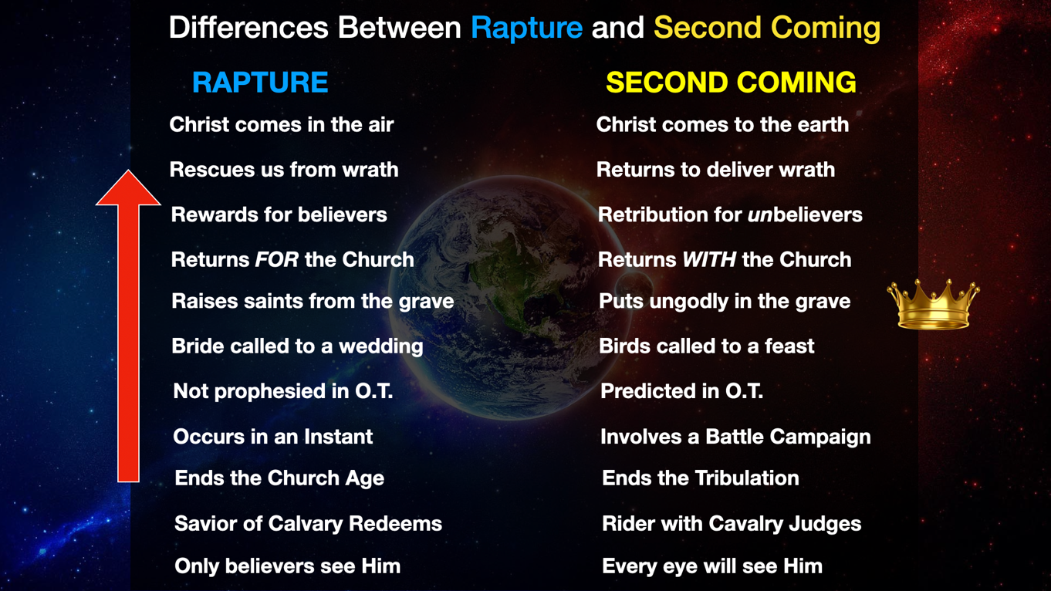

The Son of Man Arrives (Revelation 19:11-21)

His Appearing (11)
Parousia, arrival, presence, coming – 24x in the N.T., 17x referring to Jesus’ future return. 10x – Rapture. 7x Second Coming. Can be argued that the Parousia occurs in two phases. One is imminent and signless, while the other is preceded by 7 years of tribulation.
“Heaven opened” – in 4:1 heaven was opened to let John in. Here, it is to let Jesus out.
Jesus Christ is revealed. This is the climactic moment or Revelation, the crescendo of all history. The most dramatic moment of all time.
He arrives unannounced, uninvited, and unwelcome (16:15 “thief”).
He is about to receive the kingdom promised Him by His Father.

His Transportation (11)
White horse. Champion steed. Roman Generals would ride a white horse of victory through Rome following a conquest.
Jesus has traded in a humble donkey for a conquering stallion. He is mounted upon a war horse, ready to ride into earth’s atmosphere and land upon the very soil He spoke into existence thousands of years earlier.

His Character (11)
“Faithful and True” (19:11) See 1:7 (faithful witness), 3:14 (faithful and true witness). It’s just who He is. Can be trusted. He is the promise-keeping Christ (John 14:1-3; Revelation 22:7, 12, 20).
Contrasts with Satan’s lies (12:9) and Antichrist’s empire (deceived the nations 18:23)

His Judgment (11)
A righteous declaration of war (19:11). Unmerciful. His righteousness demands that he judges the world, just as He did in the days of Noah (Genesis 6:3-6).

His Appearance (19:12-13)
“Eyes are a flame of fire” (cf. 1:14) – penetrating, piercing, all-seeing (Illus – MRI, Hebrews 4:13). Eyes that once wept over Jerusalem and shed tears of sorrow at Lazarus’ grave.
Head crowned with many crowns (12 - “diadems” = rulers crowns, 12:3:13:1). “many” = He has collected all rulers’ crowns, signifying His sovereignty.
Illus – When David defeated the Ammonites in 2 Samuel 12:30, they took the king’s crown and placed it upon his head. Revelation 11:15 – “The kingdom of the world has become the kingdom of our Lord, and of His Christ, and He will reign forever and ever.”
Crown of Thorns (symbolic of bearing sin) to Crowns of Glory (symbolic of dominance and sovereignty.

His Secret Name (19:12)
No one knows. Either a new depth of meaning to His name or a new name or title.

His Garment (19:13)
“robe dipped in blood” – but not His own. It’s a symbolic preview of the blood of battle. It’s His enemies blood (cf. Isaiah 63:1-6). See also Revelation 14:14-20. Prefigures the campaign of Armageddon.

His Revealed Name (19:13)
The “Word of God” (John 1:1, 14; 1 John 1:1). Jesus is called the word (logos) of God because He is the revelation of God (John 1:18; Hebrews 1:3).

His Armies (19:14)
Armies of heaven. Who are they? The redeemed of the ages.
- The Bride, the Church (19:7-8, Bride clothes herself in fine linen, bright and clean)
- Tribulation saints who were martyred (7:9, 14; 17:14 – “called and chosen and faithful”)
- Old Testament saints (Daniel 12:1-2; Jude 14) resurrected at the second coming
- Angels (Matthew 25:31)
All these are described as “holy ones” (Zech 14:5 “all the holy ones with Him.”
“following Him on white horses” = “follow me” Matthew 4:19

His Touchdown (Zechariah 14:4; Matthew 24:3; Acts 1:11)
His feet touch the Mount of Olives, splitting it in two (Zechariah 14:4; Acts 1:10-11).
Illus - In 2004, NBC news reported that a three-year study by the Geological Survey of Israel confirmed this exact area to be at imminent risk for earthquake, having detected a major fault line running…you guessed it…right through the Mount of Olives, east to west. Just another coincidence? Or solid evidence that the Bible knows what it's talking about?

His Weapon (19:15, 21)
Only He wields a weapon in this war. Sword from His mouth. By His word, the worlds were formed (Genesis 1:3; John 1:1-3). With only a word from His mouth He healed the sick, raised the dead, calmed the storm, cursed a fig tree and shut demons’ mouths, casting them out. His word, whether spoken or written, is a double-edged sword.
Since His departure from earth, His Bride is to have been nourished on this Word, drinking it like milk and eating it like meat. His powerful Word is our source of truth and the bedrock upon which we build our lives, relationships, marriages, families and the church. It is everything the Bride needs for life and godliness.
That same Word, impossible to separate from the person of Christ Himself, will “smite the nations.” Staring into those flaming eyes, those at Armageddon will have no chance to launch a counterattack. In this, the ultimate battlefield “shock and awe,” not a trigger will be pulled nor a shot fired. Instead, they will all be instantly annihilated. Crushed like grapes in a winepress. King Jesus will obliterate His enemies, burning them with supernatural devastation with the Word proceeding out of His mouth (Zechariah 14:12).

It will be a slaughter so great that their blood will flow in some places 4½ feet high along a 200-mile-long battle line! This is why John describes this carnage this way, He “treads the wine press of the fierce wrath of God, the Almighty.” It is brutal, bloody, and beyond comprehension (Revelation 14:14, 15-20).

Neither previous judgments, nor preaching of His Word from the Two Witnesses, the 144,000, Tribulation Christians, or the angel flying in midheaven – none of these proclamations of God’s Word convinced them or moved them to repentance. Therefore, Jesus must personally return and destroy them with His Word.

It is the most extensive mass slaughter since the Great Flood in Noah’s Day.
This is no woke, social justice warrior, hipster Jesus.

His Title (19:16)
On His bloodstained robe and across his thigh are written, “KING OF KINGS AND LORD OF LORDS.”
Possibly a banner draped across His chest and thigh.
He is unrivalled. Undefeated. And Unforgiving.
He is the Hero of the ages. Our conquering Christ.
This is the Jesus the world knows nothing of, and of whom the church knows very little.
Presently, He welcomes repentant sinners. But then, He judges them all.
At Calvary, salvation was paid for.
At the Tomb, victory over death was won.
But at Armageddon, a brutal execution awaits.
…and the whole world will witness it (Revelation 1:7)
JESUS WINS and CONQUERS. And so shall we…perspective.

The birds gather for a great feast (19:17-18) – “the great supper of God”
The beasts seized and thrown alive into the Lake of Fire (19:20-21)

The history of the world and civilization is now officially over. It’s time for the sheep and the goats judgment (Matthew 25:31-46) and Jesus’ Millennial Kingdom to begin.

Why is He Returning?
- To make good on His prophesied promise (Matthew 25:31; Acts 1:9-11; Zech. 14:4)
- To defeat His enemies (Rev 19: 19-21)
- To redeem and restore national Israel (Isaiah 43:5-6; Jeremiah 30:10; 33:6-9; Ezekiel 36:24-38; 37:1-28; Isaiah 11:11; Romans 11:25-27)
- To judge Gentles (Matthew 25:31-46) sheep and goats judgment.
- To resurrect OT and Tribulation believers so they can enter the Millennial Kingdom (Rev. 20:4-6; Daniel 12:1-4)
- To bind Satan for 1,000 years (Rev. 20:1-3)
- To reign as King (Rev 19:6; Isaiah 9:6; Dan. 2:44; Matt. 19:28; Luke 1:32-33).

What is Our Response to the Truth of His Glorious Appearing? These coming prophetic realities are meant to evoke a tangible response.

Knowledge: Because you learn the mind and plan of God: His war is just and righteous. Third bowl judgment… “they deserve it” (Rev. 16:6-7). Changes our minds.

Perspective: Because you see and understand reality and humanity as He does (Rom. 8:29-30; 1 Cor. 13:12; 15:49-51; 2 Cor. 5:2-4). Alters our perspective.

Anticipation: Because you will have a front-row seat to the most epic moment in history.
You will participate in His victory parade. Motivates our service.

Rejoicing: Because you will personal experience the prophetic plan of God (Rev. 19:1-14).

Motivation: Warn the world, and invite sinners to make peace with this coming King (Luke 14:31-33)

Worship: Because He is worthy (Rev. 4:11; 5:8-14). Fall down before your coming King (Rev. 19:10; 22:20)

Holy Forever
Chris Tomlin

A thousand generations falling down in worship
To sing the song of ages to the Lamb
And all who've gone before us, and all who will believe
Will sing the song of ages to the Lamb
Your name is the highest
Your name is the greatest
Your name stands above them all
All thrones and dominions
All powers and positions
Your name stands above them all
And the angels cry, "Holy"
All creations cries, "Holy"
You are lifted high, holy
Holy forever
If you've been forgiven, if you've been redeemed
Sing the song forever to the Lamb
If you walk in freedom, if you bear His name
Sing the song forever to the Lamb
We'll sing the song forever and amen

And the angels cry, "Holy"
All creations cries, "Holy"
You are lifted high, holy
Holy forever
Hear Your people sing, "Holy"
To the King of kings, holy
You will always be holy
Holy forever
Your name is the highest
Your name is the greatest
Your name stands above them all
All thrones and dominion
All powers and positions
Your name stands above them all, Jesus
Your name is the highest
Your name is the greatest
Your name stands above them all
All thrones and dominions
All powers and positions
Your name stands above them all
And the angels cry, "Holy"
All creations cries, "Holy"
You are lifted high, holy
Holy forever (We cry, "Holy forever")
Hear Your people sing, "Holy" (We will sing)
To the King of kings, (Holy) holy (Holy forever)
You will always be holy
Holy forever

Jesus’ Second coming is visible (Rev 1:7), dramatic, violent, decisive, heroic, and regal!
And we join John in proclaiming, “Even so, come, Lord Jesus!” (Rev 22:20)

Some also include in this sequence the fall of Babylon (Jeremiah 50:9, 13-14, 23-25, 40, 43; 51:31-32; Isaiah 13:19). Studies in the Earth’s crust in this area have led Israeli seismologists to warn that a major quake is expected at any time. “The Christ Quake,” Evidence for God from Science, November 10, 2013, http://discussions.godandscience.org/viewtopic.php?t=38866 Also a fault line was discovered under the Seven Arches hotel on the top of the Mount of Olives during the time of its construction. "Its presence prohibited the Intercontinental Hotel (now called the Seven Arches Hotel) from being built on the brow of the Mount of Olives overlooking Jerusalem as originally planned. It was re-located to the south and built on more stable ground where it stands today." https://www.nbcnews.com/id/wbna3980139
The Jordan/Dead Sea Valley is part of a ‘continental transform’ – a tectonic plate boundary between the Arabian and African tectonic plates, link. Running SW-NE across this transform are ‘geologic folds’ formed when the two plates collide – as in the fold running close to the Temple Mount and the Mount of Olives. Enlarge Map. See also The Dead Sea Fault. The World Health Organization (WHO) therefore places the Jerusalem area at “high risk” from earthquake, link. Check out Jerusalem’s recent quakes. Experts expect a major earthquake soon, link. https://www.timesofisrael.com/after-tremors-experts-warn-a-huge-quake-is-the-greatest-threat-facing-israel/
Hebrews 4:12
1 Timothy 4:6; 1 Peter 2:2; Hebrews 5:11-14
2 Timothy 3:16-17; Matthew 7:24-29; Ephesians 5:25-26; Matthew 16:15-18
2 Peter 1:3-4
Compare Revelation 19:15 with 14:18-20 and Isaiah 63:2-3
Revelation 14:20. Whether this is meant to be taken literally or not, it pictures the massive bloodbath Christ will evoke among untold millions who have gathered to fight Him at Armageddon.

